# File permissions in Linux

## Project description

## Linux is a multi user operating system. Setting the file permission will prevent each other from accessing each other’s confidential data.

## Check file and directory details

I have created a directory called documents under the root directory. This is done using mkdir.

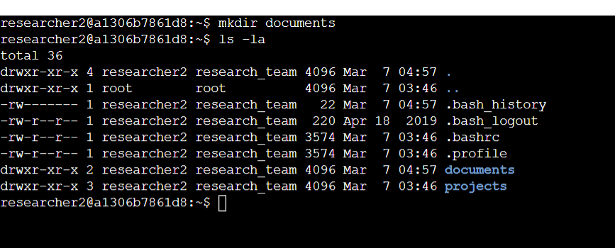

In the Documents directory I have added a file called taks.txt using the touch command followed bynthe file name.

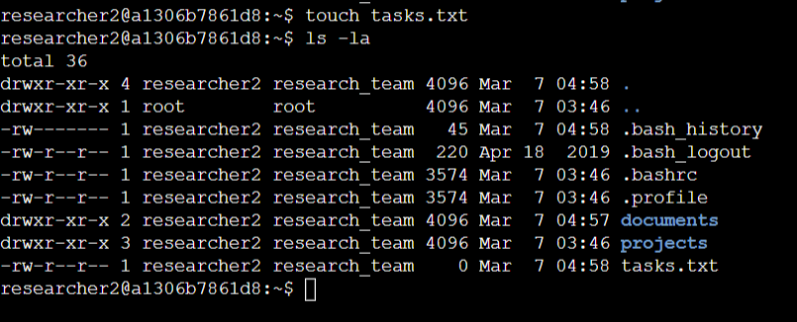

## Describe the permissions string

There are three permission groups in Linux. User the permissions apply exclusively for the individuals. Group permissions are applied to specific group that affetcs only them. Other permission applies to all the other users of the system and need to be monitored more cautiously.

## Change file permissions

To give the group write permission of the tasks file. The chmod is used to change the permission rights like read, write and execute for different groups. The ‘+’ symbol is used to add permission rights and ‘-’ to remove and ‘=’ is to set the permissions.

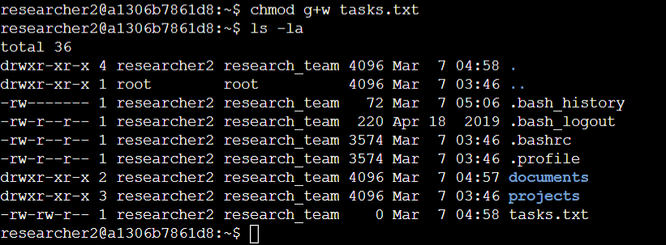

## 

## Change file permissions on a hidden file

The ls -la command is used to list the contents of the directory including the hidden files.

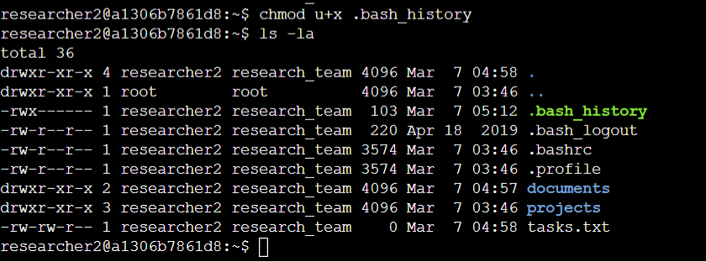

## Change directory permissions

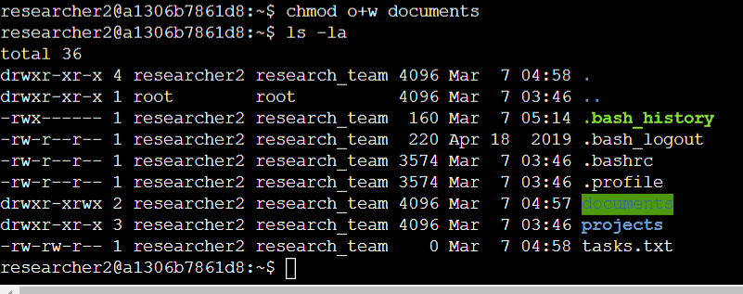

## Summary

The Linux multiuser system requires the understanding of permission rights for different groups of users. This also helps in maintaining a secure organized linux system.